Employee Skill Gap Analysis and Training Recommendation System
CO4_AT2
A CAPSTONE PROJECT REPORT
Submitted in the partial fulfilment for the Course of
CSA1012-Software Engineering
to the award of the degree of
BACHELOR OF ENGINEERING
In
Artificial intelligence and Data science
Submitted by
POOJA S(192524211)
Under the Supervision of
Dr. K. Anita Davamani
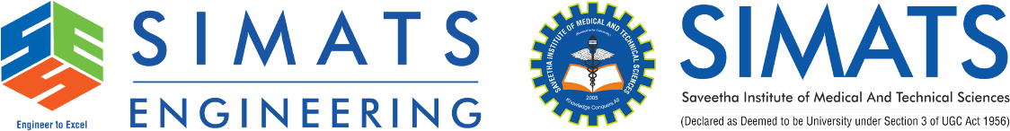
SIMATS ENGINEERING
Saveetha Institute of Medical and Technical Sciences
Chennai-602105
August-2026

S.No. | Title
1 | Background Information
2 | Project Objectives
3 | Significance and Scope
4 | Methodology Overview
5 | Problem Identification and Analysis
6 | Stakeholders and Supporting Data
7 | Solution Design and Implementation
8 | Tools and Technologies Used
9 | CI/CD Pipeline Architecture and Workflow
10 | Automated Testing and Quality Integration
11 | Deployment, Security and Rollback Strategy
12 | Monitoring and Notifications
13 | Engineering Standards Applied
14 | Results, Challenges and Improvements
15 | Reflection on Learning and Personal Development
16 | Conclusion

1. BACKGROUND INFORMATION
Organizations increasingly depend on software systems to manage employee information, skills, performance, certifications, training activities, and career development. The proposed Employee Skill-Gap Analysis and Training Recommendation System helps organizations identify differences between employees' existing competencies and the skills required for their respective job roles.
The system collects information such as employee skills, proficiency levels, performance assessments, certifications, and project experience. It analyzes this information and identifies skill gaps. Based on the identified gaps, suitable training programs and learning paths are recommended to employees.
Since the system is expected to be continuously updated, software development activities such as coding, testing, quality analysis, security verification, packaging, and deployment must be performed efficiently. Manual software delivery can be time-consuming and may result in human errors, inconsistent configurations, and deployment failures.
A Continuous Integration and Continuous Deployment (CI/CD) pipeline provides an automated solution for these challenges. It automatically integrates source-code changes, builds the application, performs testing and quality checks, packages the application, and deploys verified versions to different environments.
The proposed CI/CD pipeline therefore provides a systematic approach for maintaining the quality, security, reliability, and continuous delivery of the Employee Skill-Gap Analysis and Training Recommendation System.
2. PROJECT OBJECTIVES
The main objective of the project is to design a secure and reliable CI/CD pipeline that automates the software development and deployment process for the Employee Skill-Gap Analysis and Training Recommendation System.
The specific objectives are:
- To automate source-code integration using a version-control repository.
- To automate application building whenever new code is committed.
- To perform automated unit and integration testing.
- To identify software defects at an early stage.
- To perform automated code-quality analysis.
- To identify security vulnerabilities in source code and dependencies.
- To automate application packaging.
- To provide separate development, staging, and production environments.
- To automate deployment of verified software versions.
- To provide monitoring and notifications for pipeline activities.
- To implement rollback mechanisms for failed deployments.
- To improve the overall quality, security, reliability, and maintainability of the software.
3. SIGNIFICANCE AND SCOPE
Significance
The project is significant because modern software systems require frequent updates to meet changing user requirements and business needs. Manual testing and deployment become inefficient when software is updated regularly.
A CI/CD pipeline allows developers to integrate changes frequently and automatically verify whether the changes affect existing functionality. Automated testing reduces the possibility of defective code reaching users.
For the Employee Skill-Gap Analysis and Training Recommendation System, reliability is particularly important because the system handles employee competency information and generates training recommendations. Incorrect software behaviour may result in inaccurate skill-gap analysis or inappropriate training recommendations.
The CI/CD approach improves software quality by introducing automated testing, code-quality analysis, security checks, controlled deployment, monitoring, and rollback mechanisms. It also reduces deployment time and manual effort.
Scope
The project focuses on designing a CI/CD pipeline for the Employee Skill-Gap Analysis and Training Recommendation System.
The scope includes:
- Source-code management.
- Automated code integration.
- Application building.
- Automated unit testing.
- Integration testing.
- Code-quality analysis.
- Security scanning.
- Application packaging.
- Containerization.
- Development deployment.
- Staging deployment.
- Production deployment.
- Monitoring.
- Notifications.
- Rollback mechanisms.
The project does not focus on developing a complete enterprise-level HR application or implementing advanced artificial intelligence models. The main focus is the CI/CD architecture and automated software delivery process.
4. METHODOLOGY OVERVIEW
The proposed methodology follows a structured CI/CD workflow.
First, the application source code is maintained in a GitHub repository. Developers create changes and push them to the repository. The GitHub Actions workflow is automatically triggered when a change is committed or a pull request is created.
The pipeline then builds the application and executes automated tests. If the tests fail, the pipeline stops and the developer is notified. If the tests pass, the application undergoes code-quality and security analysis.
After successful quality checks, the application is packaged into a Docker image. The image is then deployed to the development environment for additional testing.
After development validation, the application is deployed to the staging environment. Integration and acceptance testing are performed before production deployment.
Only when all required checks are successful is the application deployed to production. Monitoring is performed after deployment, and if a serious deployment problem occurs, the system can be rolled back to the previous stable version.
5. PROBLEM IDENTIFICATION AND ANALYSIS
The development of the Employee Skill-Gap Analysis and Training Recommendation System involves multiple software components. These may include user interfaces, backend services, databases, recommendation logic, authentication mechanisms, reporting modules, and notification services.
When these components are modified frequently, manually performing the complete development and deployment process can cause several problems.
The major problems are:
- Manual integration of code changes.
- Delayed testing.
- Human errors during deployment.
- Inconsistent software environments.
- Undetected code-quality problems.
- Security vulnerabilities in dependencies.
- Difficulties in identifying defective commits.
- Longer software release cycles.
- Lack of automated rollback.
- Limited visibility into deployment status.
A CI/CD pipeline addresses these problems by automating repetitive software-development activities and establishing quality gates before deployment.
Description of the Problem
Without a CI/CD pipeline, developers may follow a process where code is developed independently, manually combined, manually tested, and finally deployed.
This process can introduce integration problems because changes made by one developer may conflict with changes made by another developer. Testing may also be delayed until the end of the development cycle.
Manual deployment can result in incorrect configuration, missing dependencies, incorrect versions, or incomplete deployment steps.
Security checks may also be performed inconsistently when they are not integrated into the development workflow.
Therefore, the proposed system requires an automated pipeline capable of continuously validating software changes and safely delivering verified versions to users.
6. STAKEHOLDERS AND SUPPORTING DATA
Stakeholders
Stakeholder | Role
Employees | Use the system to view skill gaps and training recommendations
Managers | Monitor employee development and training progress
HR Administrators | Manage employee and competency information
Developers | Develop and maintain the application
Testing Team | Validate application functionality and quality
DevOps Team | Maintain CI/CD pipeline and deployment infrastructure
Training Coordinators | Manage training programs and learning paths
Organization Management | Use reports for workforce planning
Supporting Data and Research
The design of the proposed pipeline is based on established software engineering and DevOps practices. Continuous Integration encourages developers to integrate code changes frequently, while Continuous Delivery and Deployment automate the process of delivering validated software.
Automated testing helps identify defects early in the development lifecycle. Static code analysis helps identify maintainability and code-quality issues. Security scanning helps identify vulnerable dependencies and other security risks.
Containerization provides a consistent application environment across development, staging, and production. Monitoring and rollback mechanisms further improve system reliability.
These practices provide the foundation for designing the proposed CI/CD pipeline.
7. SOLUTION DESIGN AND IMPLEMENTATION
The CI/CD pipeline design follows a structured development and implementation process.
The major steps are:
- Analyze project requirements.
- Identify software components.
- Identify CI/CD requirements.
- Select version-control and automation tools.
- Design pipeline stages.
- Define automated testing activities.
- Define quality and security gates.
- Design application packaging.
- Define deployment environments.
- Define monitoring and notification mechanisms.
- Design rollback strategy.
- Document the complete pipeline workflow.
The pipeline is designed so that failure at an important quality stage prevents defective software from progressing to the next environment.

8. TOOLS AND TECHNOLOGIES USED
Stage | Tool / Technology | Purpose
Source Control | Git | Version control
Repository | GitHub | Source-code storage
CI/CD | GitHub Actions | Pipeline automation
Programming | Python | Application development
Testing | PyTest | Automated testing
Code Quality | SonarQube | Static code analysis
Security | OWASP Dependency-Check | Dependency security analysis
Containerization | Docker | Application packaging
Container Registry | GitHub Container Registry | Store Docker images
Deployment | Docker/Kubernetes | Application deployment
Monitoring | Prometheus | Metrics collection
Visualization | Grafana | Monitoring dashboards
Notification | GitHub Actions/Email | Pipeline notifications

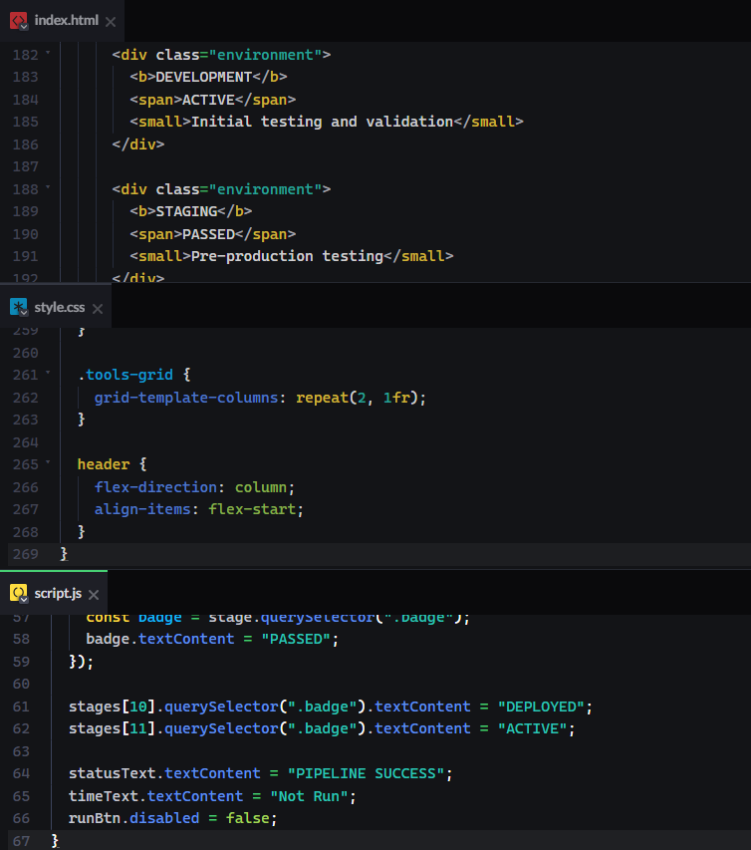

9. CI/CD PIPELINE ARCHITECTURE AND WORKFLOW
The proposed CI/CD pipeline consists of multiple automated stages.
The complete workflow is:
Developer → GitHub → Build → Unit Test → Code Quality → Security Scan → Docker Build → Development → Integration Test → Staging → Acceptance Test → Production → Monitoring
Each stage performs a specific function.
If a stage fails, the pipeline stops and the responsible developer is notified. The software is allowed to continue toward deployment only when the required checks are successful.
Pipeline Stages
Source Code Management
Developers maintain the project source code in GitHub. Each change is committed using Git.
Continuous Integration Trigger
A GitHub Actions workflow is triggered whenever code is pushed or a pull request is created.
Build
The pipeline installs required dependencies and builds the application.
Unit Testing
Automated unit tests are executed using PyTest. The pipeline stops if critical tests fail.
Code Quality Analysis
SonarQube analyzes the source code for code-quality problems, maintainability issues, and potential defects.
Security Scan
Dependencies and application components are checked for known security vulnerabilities.
Package Creation
The verified application is packaged into a Docker image.
Development Deployment
The Docker image is deployed to the development environment for further validation.
Integration Testing
Interactions between application modules and services are tested.
Staging Deployment
After successful development testing, the application is deployed to the staging environment.
Acceptance Testing
The staging version is tested against important business requirements.
Production Deployment
After successful validation and approval, the verified version is deployed to production.
Monitoring
The production application is monitored to identify failures, performance problems, and abnormal behaviour.
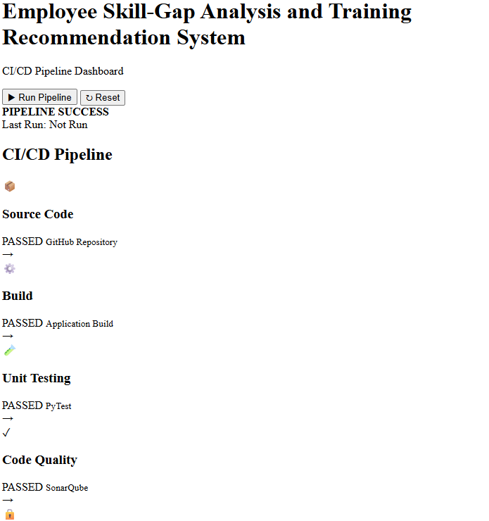
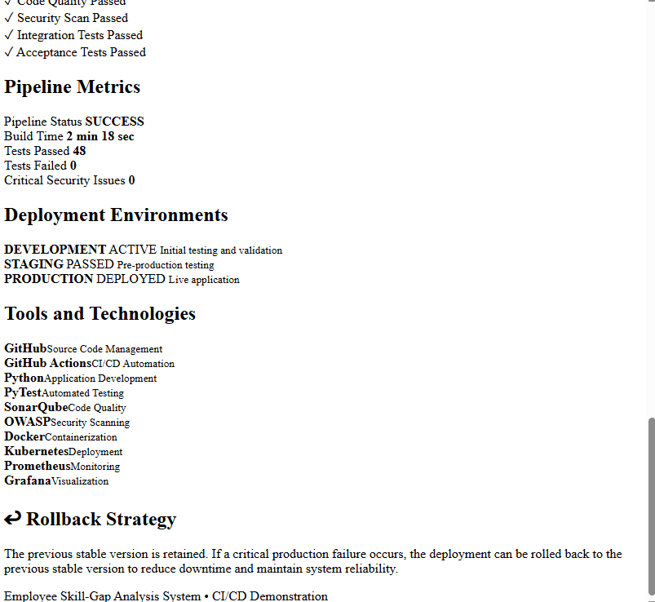

10. AUTOMATED TESTING AND QUALITY INTEGRATION
Automated testing is integrated directly into the CI/CD pipeline.
Unit Testing
Unit tests verify individual functions and modules.
Examples include:
- Employee data validation.
- Skill-level validation.
- Skill-gap calculation.
- Training recommendation logic.
- Progress calculation.
- Certification validation.
Integration Testing
Integration tests verify whether different modules work correctly together.
Examples include:
- Employee data with skill-gap analysis.
- Skill gaps with training recommendations.
- Training enrollment with progress tracking.
- Certification records with notification services.
Security Testing
Security checks verify:
- Authentication.
- Authorization.
- Dependency vulnerabilities.
- Unsafe inputs.
- Sensitive data handling.
Acceptance Testing
Acceptance tests verify that the application satisfies major business requirements before production deployment.
11. DEPLOYMENT, SECURITY AND ROLLBACK STRATEGY
Deployment Strategy
The deployment strategy uses three major environments:
Development Environment
Used by developers for initial testing and validation.
Staging Environment
Provides an environment similar to production. Integration and acceptance testing are performed here.
Production Environment
Contains the version of the application available to actual users.
The deployment flow is:
Development → Staging → Production
A version should not be deployed to production unless the required tests and quality checks are successful.
Security Strategy
Security is integrated throughout the CI/CD lifecycle.
The proposed security practices include:
- Role-based access to the repository and deployment systems.
- Secure authentication for developers.
- Protection of API keys and passwords using secrets management.
- Dependency vulnerability scanning.
- Secure Docker image configuration.
- HTTPS for application communication.
- Restricted production deployment permissions.
- Regular dependency updates.
- Security testing before production deployment.
- Logging and monitoring of important activities.
Sensitive credentials should never be directly written into source-code files.
Rollback Strategy
A rollback mechanism is required when a newly deployed version causes serious problems.
Before production deployment, the currently working version should be retained.
If the new version fails after deployment, the system can return to the previous stable version.
The rollback process is:
New Version Deployed → Problem Detected → Deployment Stopped → Previous Stable Version Restored → System Monitored
Rollback may be triggered by:
- Critical application errors.
- Failed health checks.
- Severe performance degradation.
- Security problems.
- Database or service integration failures.
This reduces downtime and protects users from defective software.
12. MONITORING AND NOTIFICATIONS
The CI/CD pipeline should provide notifications whenever important events occur.
Notifications may be generated for:
- Successful build.
- Failed build.
- Failed test.
- Security vulnerability.
- Quality-gate failure.
- Successful deployment.
- Failed deployment.
- Rollback.
Monitoring should be performed after production deployment.
Prometheus can collect application and infrastructure metrics, while Grafana can provide dashboards for monitoring.
Important monitoring indicators include:
- Application availability.
- Response time.
- Error rate.
- Resource utilization.
- Failed requests.
- Deployment status.
13. ENGINEERING STANDARDS APPLIED
The following engineering standards and best practices can be considered in the proposed project.
ISO/IEC 25010
ISO/IEC 25010 provides a software product quality model. Relevant quality characteristics include:
- Functional suitability.
- Performance efficiency.
- Compatibility.
- Usability.
- Reliability.
- Security.
- Maintainability.
- Portability.
These characteristics support the quality objectives of the CI/CD pipeline.
IEEE Software Engineering Practices
IEEE software engineering practices provide guidance for systematic software development, testing, documentation, and quality assurance.
OWASP Security Practices
OWASP security practices can be applied to identify common web-application security risks and improve secure development.
Git Version Control Practices
Git branching, commits, pull requests, and code reviews provide controlled source-code management.
14. RESULTS, CHALLENGES AND IMPROVEMENTS
Evaluation of Results
The proposed CI/CD pipeline is expected to improve the software delivery process in several ways.
Parameter | Expected Outcome
Build Automation | Automatic application builds
Testing | Early detection of defects
Code Quality | Improved maintainability
Security | Early identification of vulnerabilities
Deployment | Faster and consistent deployment
Reliability | Reduced deployment failures
Monitoring | Faster detection of production problems
Rollback | Reduced downtime during failures
Manual Effort | Reduced repetitive activities
The pipeline provides continuous verification of software changes before they reach production.
Challenges Encountered
Several challenges may occur while designing and implementing the CI/CD pipeline.
One challenge is configuring the pipeline correctly so that all stages execute in the required order. Another challenge is selecting appropriate testing tools and defining meaningful automated tests.
Managing secrets and deployment credentials securely is another important challenge. Incorrect configuration of secrets may expose sensitive information.
Container configuration may also create problems if the application behaves differently across environments.
These challenges can be addressed through proper documentation, version control, automated validation, secure secret management, and gradual testing of individual pipeline stages.
Possible Improvements
The proposed pipeline can be improved in the future by introducing additional DevOps and cloud technologies.
Possible improvements include:
- Cloud-based deployment.
- Kubernetes-based container orchestration.
- Automated database migration.
- Advanced vulnerability scanning.
- Performance testing.
- Load testing.
- Blue-green deployment.
- Canary deployment.
- Infrastructure as Code.
- Automated disaster recovery.
- Advanced monitoring and alerting.
15. REFLECTION ON LEARNING AND PERSONAL DEVELOPMENT
The CI/CD pipeline design exercise provided an opportunity to understand how software engineering concepts are applied in a real-world development environment. The project helped in understanding the importance of automation, continuous integration, continuous deployment, testing, quality assurance, security, monitoring, and reliability.
Key Learning Outcomes
Academic Knowledge
The project strengthened understanding of software engineering, DevOps, software testing, quality assurance, version control, and deployment concepts.
Technical Skills
The project provided knowledge of tools such as Git, GitHub, GitHub Actions, PyTest, SonarQube, Docker, and monitoring technologies.
Problem-Solving and Critical Thinking
Designing the pipeline required identifying possible failures at different stages and developing suitable solutions. Quality gates, security checks, monitoring, and rollback mechanisms were designed to handle these problems.
Personal and Professional Development
The project improved understanding of software engineering and DevOps practices. It developed technical knowledge of version control, automated testing, CI/CD pipelines, containerization, security checks, deployment environments, monitoring, and rollback.
The experience also improved problem-solving and system-design skills. Understanding how software moves from development to production provided practical knowledge that can be applied to future software projects.
16. CONCLUSION
The proposed CI/CD pipeline provides an automated and systematic approach for developing, testing, securing, and deploying the Employee Skill-Gap Analysis and Training Recommendation System.
The pipeline integrates source-code management, automated building, unit testing, code-quality analysis, security scanning, containerization, development deployment, integration testing, staging validation, production deployment, monitoring, and rollback.
The use of separate development, staging, and production environments reduces deployment risk and ensures that software changes are validated before reaching users. Automated testing and quality checks help identify defects early, while security scanning improves protection against vulnerabilities.
The monitoring and rollback mechanisms improve reliability by allowing production problems to be detected and previous stable versions to be restored when necessary.
Overall, the proposed CI/CD pipeline demonstrates how DevOps practices can improve software quality, deployment speed, security, reliability, and maintainability. It provides a suitable foundation for the continuous development and delivery of the Employee Skill-Gap Analysis and Training Recommendation System.

